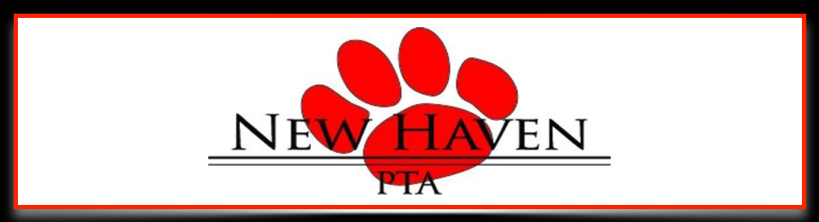

The New Haven Elementary PTA needs your help!

The PTA is hosting the **2nd Annual Tiger Tee-Off Golf Outing** to be held on **Saturday, September 29, 2018**, at **Eagle Creek Country Club.**

The New Haven PTA is incorporated as a 501(c)(3), and is funded by parents, community, and local sponsors. The PTA provides numerous classroom and extra-curricular activities for all of New Haven’s students, so funding these activities is very important. All contributions to the PTA are fully tax-deductible.

We invite you to join us as a sponsor for this year’s event by choosing from one of our Sponsorship Opportunity Levels, and/or supporting us through donations of various prizes and raffle items. Sponsorship levels range from $1000 to $100, and are listed on the enclosed page. The outing will be publicized through the school’s website and other forms of social media as well, so sponsorship will provide exposure for your company to not only the golfers participating in the outing but also thousands of families across Northern Kentucky.

We are anticipating a highly successful and well-attended golf outing. We would appreciate any help you could give us for this event. Companies, like yours, are vital to helping us provide activities to the nearly one thousand students at New Haven, and for that we are forever grateful.

To become a sponsor, please contact me at the email address or phone number listed below.

We thank you in advance for your support of New Haven and its students.

Sincerely,



Bill Thornton

Tiger-Tee Off Outing Chairman

[Billthornton25@gmail.com](mailto:Billthornton25@gmail.com)

(513) 504-6001 cell



2018 Sponsor Levels

**Sponsorship Level Contribution Perks**

**Title Sponsor** $1000 Top line recognition on all outing publicity

Entrance fee for 4 golfers

Signage at registration table

Recognition at dinner

**Dinner Sponsor** $500 Signage at dinner

Signage at registration table

Recognition at dinner

**Cart Sponsor** $400 Company name and logo on all cart signs

Signage at registration table

Recognition at dinner

**Drink Sponsor** $200 Company name and logo on all drink tickets

Signage at registration table

Recognition at dinner

**Hole Sponsor** $100 Signage with company name at tee box

Recognition at dinner